Database Design Document

# Introduction

The creation of a database from Customer and Product Sample Data, with the design of the ERD and DDL.

# Assumption and Constraints

* Product table has lacked of relevant information for normalization or integration of data.
* Entity relationships were created based on concepts I created, due to lack of information.
* The business model was unknown, so assumptions had to be made.

# Identified Issues

This was unclear that which information should and needed to be included into the normalized tables, so I made some assumptions through the ThinkCube Invoice file.

# Personnel

Identify who is working on the project, responsibilities, etc. Example jobs below. It is possible to be more than one of these.

* Analyst: Dadallage Samarasinghe
* Architect: Dadallage Samarasinghe
* Quality Assurance: Dadallage Samarasinghe
* Documentation Specialist: Dadallage Samarasinghe

# Entities

Database Name: ThinkCube_Inventory Revision: 1

Date: 11th of April 2021

Author: Dadallage Samarasinghe

|  |  |  |
| --- | --- | --- |
| Entity Name | Entity Type | Relates to |
| Customer | Table |  |
| Address | Table | Customer, Province |
| Province | Table |  |
| Shipment | Table |  |
| Product | Table |  |
| Invoice | Table | Shipment, Customer |
| Invoice_Line | Table | Product, Invoice |
| Employee | Table | Invoice |
|  |  |  |

Notes: Some entity tables have relation with other tables.

__________________________________________________________________

__________________________________________________________________

__________________________________________________________________

__________________________________________________________________

# Entity Details

## Fields form – <Customer >

Database Name: ThinkCube_Inventory Revision: 1

Entity Name: Customer Date: 11th of April 2021

Author: Dadallage Samarasinghe

|  |  |  |  |
| --- | --- | --- | --- |
| Field Name | Data type | Field Properties | Relates to |
| Customer_ID | BIGINT | PRIMARY KEY |  |
| First_Name | VARCHAR(30) | NOT NULL |  |
| Last_Name | VARCHAR(30) | NOT NULL |  |
| Phone_Number | VARCHAR(150) | NOT NULL |  |
| Email | VARCHAR(15) | NOT NULL |  |
|  |  |  |  |
|  |  |  |  |
|  |  |  |  |
|  |  |  |  |
|  |  |  |  |
|  |  |  |  |
|  |  |  |  |

Notes: Customer_ID is a primary key and the values for field names can’t be NULL.

__________________________________________________________________

__________________________________________________________________

__________________________________________________________________

## Fields form – <Address >

Database Name: ThinkCube_Inventory Revision: 1

Entity Name: Address Date: 11th of April 2021

Author: Dadallage Samarasinghe

|  |  |  |  |  |
| --- | --- | --- | --- | --- |
| Field Name | Data type | Field Properties | | Relates to |
| Customer_ID | BIGINT | FOREIGN KEY | | Customer |
| Street_Address | VARCHAR(100) | NOT NULL | |  |
| P_O_Box | VARCHAR(10) |  |
| Postal_Code | CHAR(7) | NOT NULL | |  |
| Apartment_Number | VARCHAR(5) |  | |  |
| City | VARCHAR(100) | NOT NULL | |  |
| Province | CHAR(2) | FOREIGN KEY | | Province |
|  |  |  | |  |
|  |  |  | |  |
|  |  |  | |  |
|  |  |  | |  |
|  |  |  | |  |

Notes: Customer_ID and Provice are Foreign keys. Street_Address, Postal_Code, and City cannot take NULL Values.

__________________________________________________________________

__________________________________________________________________

__________________________________________________________________

## Fields form – <Province >

Database Name: ThinkCube_Inventory Revision: 1

Entity Name: Province Date: 11th of April 2021

Author: Dadallage Samarasinghe

|  |  |  |  |
| --- | --- | --- | --- |
| Field Name | Data type | Field Properties | Relates to |
| Province_Code | CHAR(2) | PRIMARY KEY |  |
| Province_Name | VARCHAR(20) | NOT NULL |  |
|  |  |  |  |
|  |  |  |  |
|  |  |  |  |
|  |  |  |  |
|  |  |  |  |
|  |  |  |  |
|  |  |  |  |
|  |  |  |  |
|  |  |  |  |
|  |  |  |  |

Notes: Province_Code is a Primary key.

__________________________________________________________________

__________________________________________________________________

__________________________________________________________________

## Fields form – <Shipment >

Database Name: ThinkCube_Inventory Revision: 1

Entity Name: Shipment Date: 11th of April 2021

Author: Dadallage Samarasinghe

|  |  |  |  |
| --- | --- | --- | --- |
| Field Name | Data type | Field Properties | Relates to |
| Shipping_Code | CHAR(3) | PRIMARY KEY |  |
| Shipping_Method | VARCHAR(10) | NOT NULL |  |
| Shipping_Terms | INTEGER | NOT NULL |  |
| Delivery_Date | DATE | NOT NULL |  |
|  |  |  |  |
|  |  |  |  |
|  |  |  |  |
|  |  |  |  |
|  |  |  |  |
|  |  |  |  |
|  |  |  |  |
|  |  |  |  |

Notes: Shipping_Code is a primary key. Fields can’t take NULL values.

__________________________________________________________________

__________________________________________________________________

__________________________________________________________________

## Fields form – <Invoice>

Database Name: ThinkCube_Inventory Revision: 1

Entity Name: Invoice Date: 11th of April 2021

Author: Dadallage Samarasinghe

|  |  |  |  |
| --- | --- | --- | --- |
| Field Name | Data type | Field Properties | Relates to |
| Invoice_Number | BIGINT | PRIMARY KEY |  |
| Customer_ID | BIGINT | FOREIGN KEY | Customer |
| Date_Of_Purchase | DATE | NOT NULL |  |
| Shipping_Code | CHAR(3) | FOREIGN KEY | Shipment |
| Due_Date | DATE | NOT NULL |  |
| Payment_Terms | INTEGER | NOT NULL |  |
| Employee_ID | BIGINT | FOREIGN KEY | Employee |
|  |  |  |  |
|  |  |  |  |
|  |  |  |  |
|  |  |  |  |
|  |  |  |  |

Notes: Invoice_Number is a primary key. Customer_ID, Shipping_Code and Employee_ID are foreign keys. Fields can’t take NULL values.

__________________________________________________________________

__________________________________________________________________

__________________________________________________________________

## Fields form – <Invoice_Line >

Database Name: ThinkCube_Inventory Revision: 1

Entity Name: Invoice_Line Date: 11th of April 2021

Author: Dadallage Samarasinghe

|  |  |  |  |
| --- | --- | --- | --- |
| Field Name | Data type | Field Properties | Relates to |
| Product_Code | CHAR(3) | PRIMARY FOREIGN KEY | Product |
| Invoice_Number | BIGINT | PRIMARY FOREIGN KEY | Invoice |
| Line_Price | NUMERIC(15,2) | NOT NULL |  |
| Quantity_Purchased | INTEGER | NOT NULL |  |
|  |  |  |  |
|  |  |  |  |
|  |  |  |  |
|  |  |  |  |
|  |  |  |  |
|  |  |  |  |
|  |  |  |  |
|  |  |  |  |

Notes: There is an Associative entity; product_code and invoice_number are composite keys.

__________________________________________________________________

__________________________________________________________________

__________________________________________________________________

## Fields form – <Product >

Database Name: ThinkCube_Inventory Revision: 1

Entity Name: Product Date: 11th of April 2021

Author: Dadallage Samarasinghe

|  |  |  |  |
| --- | --- | --- | --- |
| Field Name | Data type | Field Properties | Relates to |
| Product_Code | CHAR(5) | PRIMARY KEY |  |
| Product_Name | VARCHAR(30) | NOT NULL |  |
| Product_Price | NUMERIC(15,2) | NOT NULL |  |
| Product_QOH | INTEGER | NOT NULL |  |
| Product_Discount | DECIMAL(15,2) | NOT NULL |  |
|  |  |  |  |
|  |  |  |  |
|  |  |  |  |
|  |  |  |  |
|  |  |  |  |
|  |  |  |  |
|  |  |  |  |

Notes: Product_Code is a primary key. Fields can’t take NULL values.

__________________________________________________________________

__________________________________________________________________

__________________________________________________________________

## Fields form – <Employee >

Database Name: ThinkCube_Inventory Revision: 1

Entity Name: Employee Date: 11th of April 2021

Author: Dadallage Samarasinghe

|  |  |  |  |
| --- | --- | --- | --- |
| Field Name | Data type | Field Properties | Relates to |
| Employee_ID | BIGINT | PRIMARY KEY | Invoice |
| First_Name | VARCHAR(30) | NOT NULL |  |
| Last_Price | VARCHAR(30) | NOT NULL |  |
| Job_Position | VARCHAR(15) |  |  |
|  |  |  |  |
|  |  |  |  |
|  |  |  |  |
|  |  |  |  |
|  |  |  |  |
|  |  |  |  |
|  |  |  |  |
|  |  |  |  |

Notes: Employee_ID is a primary key. Fields can’t take NULL values.

__________________________________________________________________

__________________________________________________________________

__________________________________________________________________

# Basic ERD

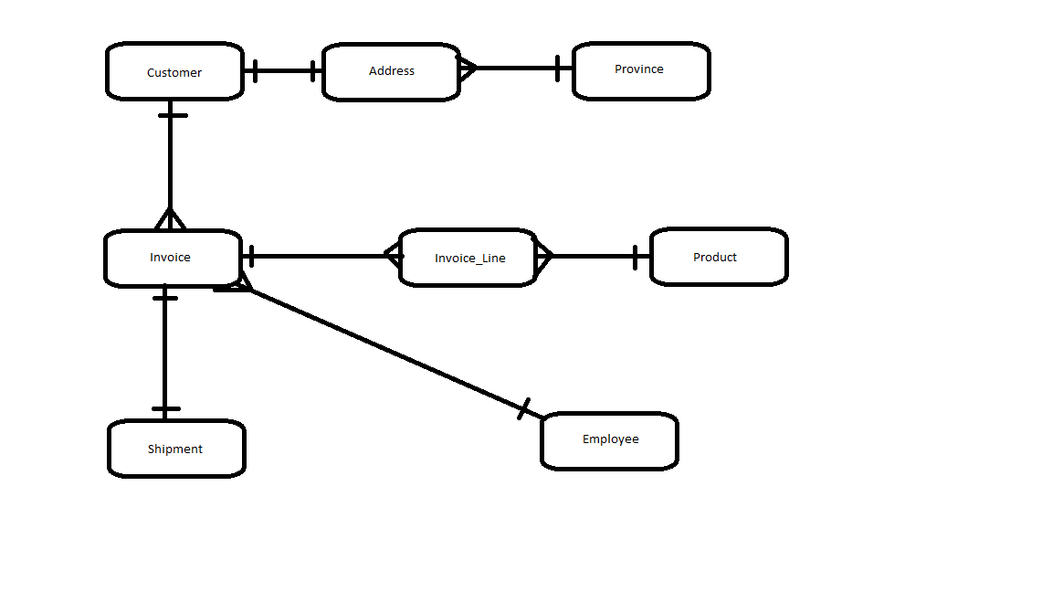

# Physical ERD

